# Technical architecture :

As our lives are very busy these days, we often feel we need more than 24 hrs. a day to cope up with everything we have in our schedule. Well, that's not possible but reducing the time by changing the conventional method of reading news can help. Just tell us what market news you're interested in and get a quick peek for the day. Only read what you feel is relevant and save your time. This app helps you to query for all information about Indices, Commodities, Currencies, Future Rates, Bonds etc. as on official websites

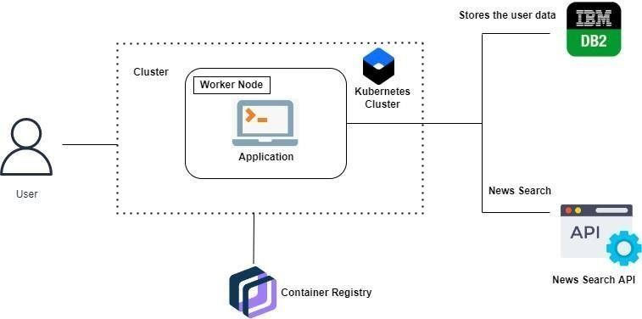

**Project Workflow: -**

* The user interacts with the application.
* Registers by giving the details.
* Integrate the application with news APIs and store the data in the database.
* The database will have all the details and the user can search the news by using a search bar.

# Table-1 : Components & Technologies:

|  |  |  |  |
| --- | --- | --- | --- |
| **S. No** | **Component** | **Description** | **Technology** |
| 1. | User Interface | User interacts with the application using web development, which is used to get the  information needed for the user. | HTML, CSS, JavaScript / React Js etc. |
| 2. | Application Logic | The Logic depends on the extraction news from  the database | Python |
| 3. | Database | Data type , configuration etc. | MYSQL, NOSQL, etc. |
| 4. | Cloud database | Database service on cloud | IBM DB2, IBM Cloud net etc.. |
| 5. | File storage | File storage requirements | IBM Block Storage or Other Storage  Service or Local File system. |
| 6. | Infrastructure ( server/cloud) | Application deployment on local system / cloud local server configuration : Docker Cloud server configuration : Kubernetes | Local, Cloud Foundry, Kubernetes, etc. |
| 7. | File Storage | File storage requirements | IBM Block Storage or Other Storage  Service or Local File system |
| 8. | External API-1 | Purpose of External API used in the application | IBM Weather API, etc. |
| 9. | External API-2 | Purpose of External API used in the application | Adhar API, etc. |
| 10. | Machine Learning Model | Purpose of Machine Learning Model | Object Recognition Model, etc. |